Dear Garrison Road parent/guardian,

Over the past few weeks, we have been telling you about our partnership with School Cash, an online portal that allows you to pay for any school service, product or event, all online. The system is now active and you can register any time by visiting our school website and clicking on the School Cash Online button.

Registration should take less than five minutes.

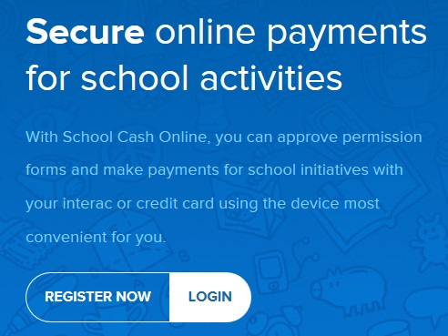
Register:
- Visit www.dsbn.org/schoolcash and select “Register Now”
- Complete the three registration steps
- NOTE: You must create your profile using your name and not your children’s

Confirm Your Account:
- You will receive a confirmation email from School Cash Online
- Click on the link provided*
- Sign in to your account using your email and password

Add Student:
- This will connect your children to your account
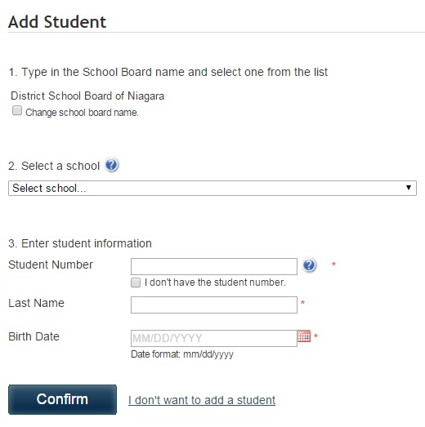
- Confirm the school board name – DSBN
- Select our school
- Enter your child’s name and birth date
- Select continue
- Confirm your child and select continue
- Your child has been added

View Items or Add Another Student
- If you have more children, select “Add Another Student” and repeat the above steps
- If you wish to view a listing of items available for purchase, click “View Items for Students”

*To ensure the highest level of security, School Cash Online does not support TLS 1.0. Therefore, if you are using Internet Explorer version 9.0 or lower, please refer to the attached instructions on how to access the link within the confirmation email. Alternatively, you can copy the link and paste in Google Chrome.

If you experience any difficulty registering for this service, you can access support and a list of Frequently Asked Questions by visiting www.dsbn.org/schoolcash and clicking on “Support.”

